DATA 366 (Introduction to Multivariate Statistics)

Instructor: Dr. Nazish Shahid

Homework-Week 1

Q1.



For the above data set

- Plot the scatter diagrams $(x_{2}, x_{3})$ and $(x_{1}, x_{3})$. Comment on patterns.
- Compute the $\overline{x}$, $S_{n}$ and $R$ arrays for $(x_{1}, x_{2}, x_{3})$.

Q2.
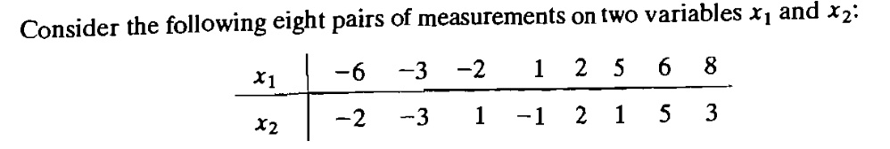

- Consider a new measurement $P=\left(x_{1}, x_{2}\right)=(4, -2)$. Calculate the Euclidean distance between $P$ and origin $O(0,0)$.
- Calculate the statistical distance between $P$ and origin $O(0,0)$.

Q3.
